Practicum Final Exam –Even Semester Year 2020/2021
Subject |  |  | COMP6048 - Data Structures |  |  | 
Class | : | BA08 / PF01 / PG01 / SF01 / SG01 |  | Start Date | : 22 June 2021
Lecturer | : | D4458 - Diana, S.Kom., M.T.I.  D4459 - Gredion Prajena, S. Kom., M.T.I.  D4730 - Rini Wongso, S.Kom., M.T.I |  | Start Time | : 13:20
Lecturer | : |  |  | End Date | : 22 June 2021
Lecturer | : |  |  | End Time | : 15:20

PERATURAN UJIAN:
Exam Regulations:
- Mahasiswa tidak diperbolehkan berdiskusi dan/atau bekerja sama dengan peserta ujian lainnya
Student is not allowed to discuss and/or work together with other exam participants
- Mahasiswa tidak diperbolehkan untuk membuka dan menyalin dari BUKU atau CATATAN, VIDEO dari pengajar (recording kelas, VBL, Youtube, dsb) dan REFERENSI lainnya
Student isn't allowed to open and copy from any resources such as notes, videos (class recording, VBL, Youtube, etc) and other references
- Mahasiswa tidak diperbolehkan membuka dan menyalin jawaban dari internet (google, stackoverflow, dsb)
Student isn't allowed to open and copy answer from the internet (google, stackoverflow, etc)
- Asisten BERHAK memberi nilai 0 (NOL) bagi peserta ujian yang melakukan segala bentuk kecurangan
Assistant is able to give 0 (ZERO) score for exam participant who does any cheating actions
- Kumpulkan jawaban tepat pada waktunya, apabila terlambat mengumpulkan maka jawaban tidak akan dikoreksi dan nilai mahasiswa adalah 0
Submit the answer on time, if not, then the answer will not be checked, and the students will receive 0 (ZERO)
- Bila Anda tidak membaca peraturan ini, maka Anda dianggap telah membaca dan menyetujuinya
If you have missed to read these regulations, so you are considered to have read and agreed on it

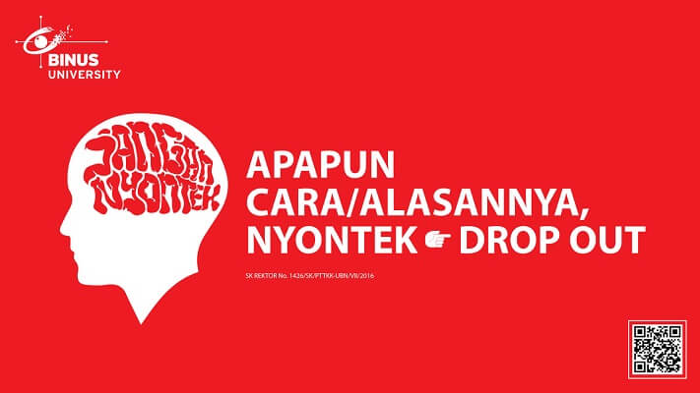

SOFTWARE YANG DIGUNAKAN:
Software will be used:
- Dev-C++ 5.11

FILE YANG DIKUMPULKAN:
File must be collected:
- [NIM].CPP

PERHATIAN!
Attention!
- Bagi yang mengerjakan tidak sesuai dengan soal, maka akan diberikan nilai NOL (0)
For those who do not work in accordance with the exam case will be marked as ZERO (0)
- Bagi yang mengerjakan tidak sesuai dengan software dan versi yang telah ditetapkan, maka akan tetap dikoreksi dengan software dan versi yang telah ditetapkan
For those who do not work in accordance with the software and specific version will be corrected by the predefined software and version
- Kompres semua jawaban yang akan diunggah. Pastikan format pengumpulan nama file dan ekstensi sesuai dengan format berikut: [NIM]-[NAMA].zip
Compress all file that will be uploaded. Make sure the format for collecting file name and extension according to the following format: [NIM]-[NAME].zip

Soal
Case

BJ Kenangan Boba
BJ Kenangan Boba is an application used by the admin of BJ Kenangan Boba to manage the drink menu. This application will be developed using AVL Tree. The descriptions of the program are:
- The program consists of 3 menus:
1. View Drink
2. Insert Drink
3. Delete Drink
4. Exit
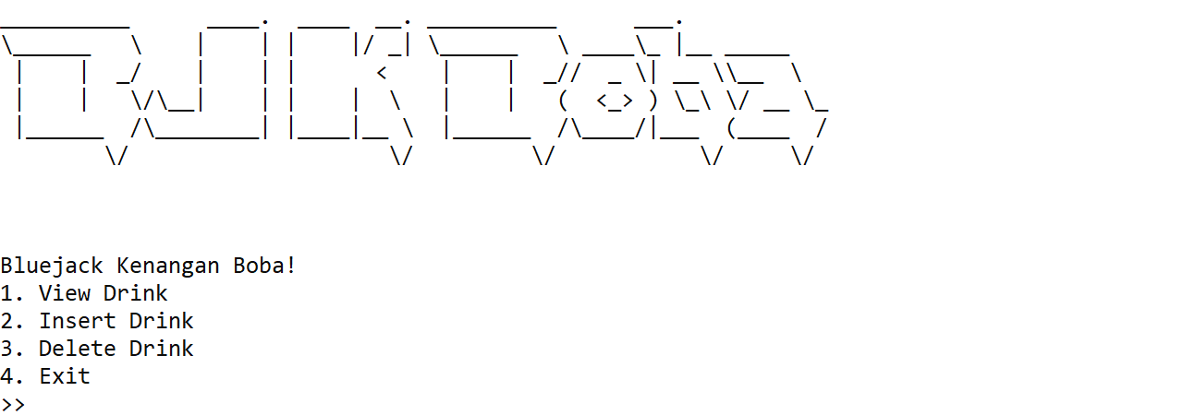
Figure 1. Main Menu
- If user chooses View Drink (Menu 1):
  - If there is no data in the AVL, print “There is no boba here!”
  - Otherwise, ask user to input display method. Validate that the method must be either equals to “Pre”, “In”, or “Post” (case sensitive)
Figure 2. Choose Show Method
    - If user chooses “Pre”, show the data using Pre-Order method
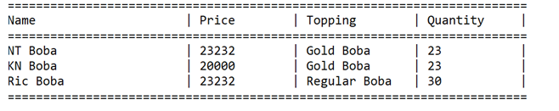
Figure 3. View Food in Pre-Order
    - If user chooses “In”, show the data using In-Order method
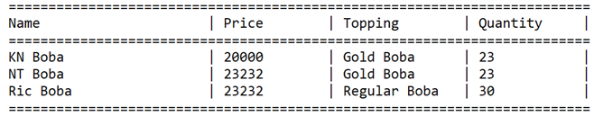
Figure 4. View Food in In-Order
    - If user chooses “Post”, show the data using Post-Order method
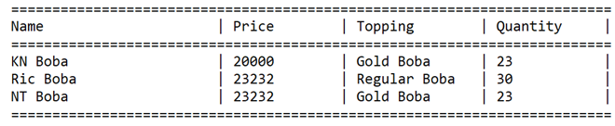
Figure 5. View Food in Post-Order
- If user chooses Insert Drink (Menu 2):
  - Ask user to input the following data:
    - Drink Name
      - Validate that the name must end with “Boba”
    - Drink Price
      - Validate that the price must be between 20000 and 50000
    - Drink Topping
      - Validate that the Topping must be either equals to “Gold Boba” or “Regular Boba”
    - Drink Quantity
      - Validate that the Quantity must be between 1 and 50
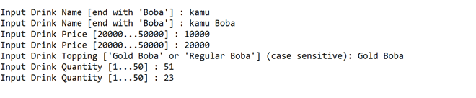
Figure 6. Insert Food
  - After that, display all data and show input confirmation and validate the input must be “yes” or “no” (case insensitive)
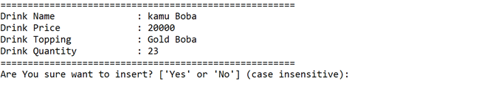
Figure 7. Show Confirmation
  - If the user input “yes”, then push all data to AVL Tree with Drink Name as key. If the user input “no”, then redirect to main menu
- If user chooses Delete Drink (Menu 3):
  - If there is no data in the AVL, print “No Data!”
  - Otherwise, ask user to input food name
    - If user input ”cancel”, redirect back to main menu
    - Otherwise, ask user to input food name. Validate food name must exist in the AVL Tree
    - If data exists, show confirmation message and validate the input must be either “yes” or “no” (case insensitive)
    - If user chooses “yes” then delete the food from the AVL. Otherwise, redirect back to main menu
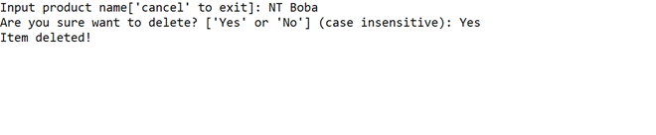
Figure 8. delete drink
- If user chooses Exit (Menu 4), delete all data in the AVL and close the program

Please run the EXE file to see the sample program

